**INTRODUCTION**

The Sustainable Forestry Initiative® (SFI) [2022 Standards](https://forests.org/sfi-2022-standards/) include requirements that promote and conserve Forests with Exceptional Conservation Value (FECV), which includes critically imperiled (G1) and imperiled (G2) species. This fact sheet summarizes the analysis of FECV habitat within this ecoregion and provides habitat management recommendations that would benefit species potentially found here.   
  
**HABITAT TYPES**

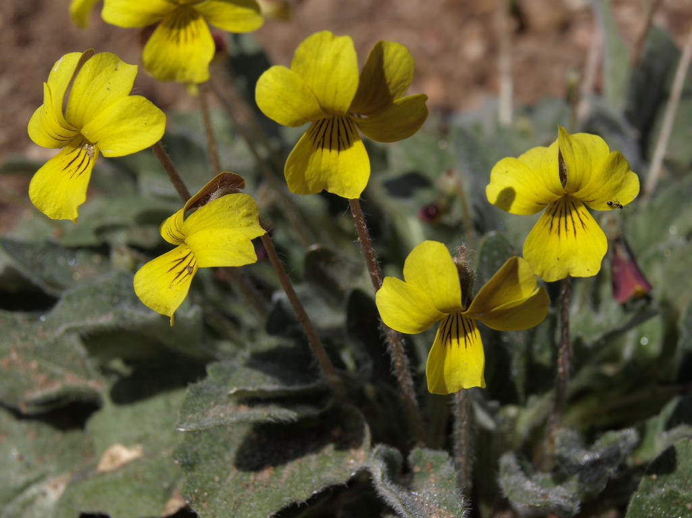

**Bright Yellow Violet**

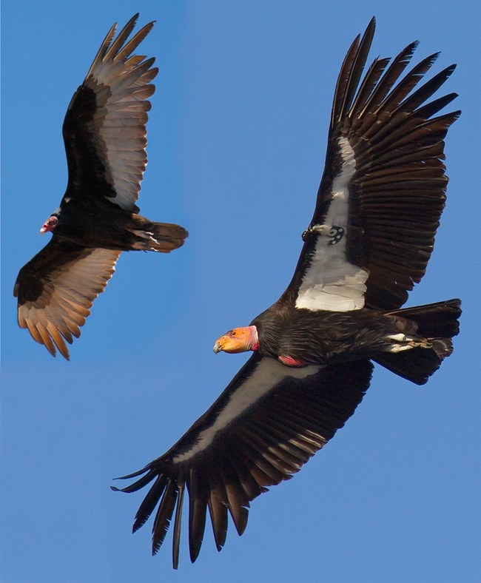

**California Condor**

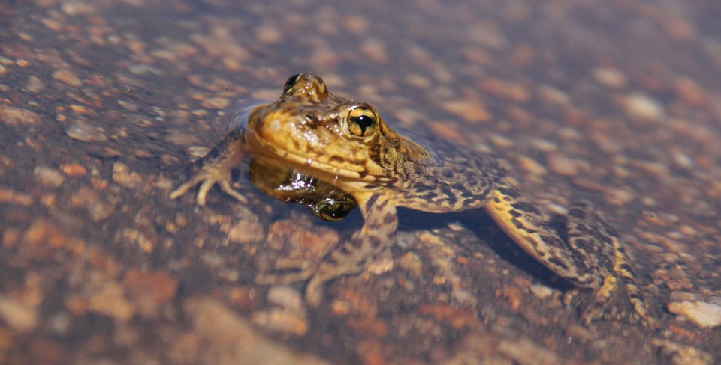

**Sierra Nevada   
Yellow-legged Frog**

* Mixed Conifer Forest
* Riparian/Streams/Wetland
* Special Sites (Bare Rock/Talus, Cliff, Desert, Grassland, Shrubland/Chaparral)

**MIXED CONIFER FOREST MANAGEMENT**

* Protect known locations
* Retain legacy trees, stumps, and logs
* Retain large diameter trees with cavities or broken tops
* Leave skips and gaps with dense shrub component
* Retain large slash into piles

**RIPARIAN/STREAMS/WETLANDS MANAGEMENT**

* Protect known locations
* Maintain well vegetated riparian buffers
* Plant a diversity of both hardwood and conifer trees
* Retain large diameter trees near streams, rivers and wetlands
* Buffer wetlands, springs, and headwater areas

**SPECIAL SITES MANAGEMENT**

* Protect known locations
* Maintain and buffer special sites

|  |  |  |  |
| --- | --- | --- | --- |
| **SCIENTIFIC NAME** | **COMMON NAME** | **HABITAT** | **STATUS** |
| *Polemonium chartaceum* | [Mason's Sky Pilot](https://explorer.natureserve.org/Taxon/ELEMENT_GLOBAL.2.905852) | Bare Rock/Talus | G2 |
| *Hackelia sharsmithii* | [Sharsmith's Stickseed](https://explorer.natureserve.org/Taxon/ELEMENT_GLOBAL.2.149579) | Bare Rock/Talus | G2 |
| *Hesperia miriamae* | [Sierra Skipper](https://explorer.natureserve.org/Taxon/ELEMENT_GLOBAL.2.107362) | Bare Rock/Talus | G2 |
| *Hesperidanthus jaegeri* | [Jaeger's Caulostramina](https://explorer.natureserve.org/Taxon/ELEMENT_GLOBAL.2.133362) | Cliff | G2 |
| *Lupinus holmgrenianus* | [Holmgren's Lupine](https://explorer.natureserve.org/Taxon/ELEMENT_GLOBAL.2.148281) | Desert | G2 |
| [*Nemacladus inyoensis*](https://explorer.natureserve.org/Taxon/ELEMENT_GLOBAL.2.1167612) |  | Desert | G2 |
| *Bombus crotchii* | [Crotch's Bumble Bee](https://explorer.natureserve.org/Taxon/ELEMENT_GLOBAL.2.834085) | Grassland/herbaceous | G2 |
| *Draba monoensis* | [White Mountains Draba](https://explorer.natureserve.org/Taxon/ELEMENT_GLOBAL.2.160922) | Grassland/Herbaceous | G2 |
| *Gymnogyps californianus* | California Condor | Mixed Conifer Forest | G1 |
| *Boechera pinzliae* | [Pinzl's Rockcress](https://explorer.natureserve.org/Taxon/ELEMENT_GLOBAL.2.128570) | Mixed Conifer Forest | G1 |
| *Cryptantha roosiorum* | [Bristlecone Cryptantha](https://explorer.natureserve.org/Taxon/ELEMENT_GLOBAL.2.135035) | Mixed Conifer Forest | G2 |
| *Trifolium dedeckerae* | [Dedecker's Clover](https://explorer.natureserve.org/Taxon/ELEMENT_GLOBAL.2.140747) | Mixed Conifer Forest | G2 |
| *Ericameria gilmanii* | [Gilman Goldenweed](https://explorer.natureserve.org/Taxon/ELEMENT_GLOBAL.2.152848) | Mixed Conifer Forest | G2 |
| *Perityle inyoensis* | [Inyo Rockdaisy](https://explorer.natureserve.org/Taxon/ELEMENT_GLOBAL.2.142728) | Mixed Conifer Forest | G2 |
| *Astragalus monoensis* | [Mono Milkvetch](https://explorer.natureserve.org/Taxon/ELEMENT_GLOBAL.2.155316) | Mixed Conifer Forest | G2 |
| *Ivesia aperta* | [Sierra Valley Ivesia](https://explorer.natureserve.org/Taxon/ELEMENT_GLOBAL.2.156148) | Mixed Conifer Forest | G2 |
| *Pyrgulopsis aardahli* | [Benton Valley Springsnail](https://explorer.natureserve.org/Taxon/ELEMENT_GLOBAL.2.114768) | Riparian/Streams | G1 |
| *Pyrgulopsis perturbata* | [Fish Slough Springsnail](https://explorer.natureserve.org/Taxon/ELEMENT_GLOBAL.2.110868) | Riparian/Streams | G1 |
| *Pyrgulopsis owensensis* | [Owens Valley Springsnail](https://explorer.natureserve.org/Taxon/ELEMENT_GLOBAL.2.112314) | Riparian/Streams | G1 |
| *Desmona bethula* | Amphibious Caddisfly | Riparian/Streams | G2 |
| *Ivesia sericoleuca* | [Plumas Ivesia](https://explorer.natureserve.org/Taxon/ELEMENT_GLOBAL.2.128826) | Riparian/Streams | G2 |
| *Rana sierrae* | Sierra Nevada Yellow-legged Frog | Riparian/Streams | G2 |
| *Pyrgulopsis wongi* | [Wong's Springsnail](https://explorer.natureserve.org/Taxon/ELEMENT_GLOBAL.2.113112) | Riparian/Streams | G2 |
| *Eriogonum eremicola* | [Wildrose Canyon Buckwheat](https://explorer.natureserve.org/Taxon/ELEMENT_GLOBAL.2.137256) | Shrubland/Chaparral | G1 |
| *Cusickiella quadricostata* | [Bodie Hills Cusickiella](https://explorer.natureserve.org/Taxon/ELEMENT_GLOBAL.2.135985) | Shrubland/Chaparral | G2 |
| *Viola aurea* | [Bright Yellow Violet](https://explorer.natureserve.org/Taxon/ELEMENT_GLOBAL.2.157446) | Shrubland/Chaparral | G2 |
| *Lupinus duranii* | [Mono Lake Lupine](https://explorer.natureserve.org/Taxon/ELEMENT_GLOBAL.2.153699) | Shrubland/Chaparral | G2 |
| *Ivesia webberi* | [Webber Ivesia](https://explorer.natureserve.org/Taxon/ELEMENT_GLOBAL.2.151761) | Shrubland/Chaparral | G2 |
| *Cyprinodon radiosus* | [Owens Pupfish](https://explorer.natureserve.org/Taxon/ELEMENT_GLOBAL.2.104524) | Wetland | G1 |
| *Plagiobothrys parishii* | [Parish's Popcorn-flower](https://explorer.natureserve.org/Taxon/ELEMENT_GLOBAL.2.154161) | Wetland | G1 |

*\*species links provided when available*

